Name: Nawal Fatima
Roll no: 94
Section: BSAI-3B
Lab task 2

Introduction:
Is lab mein hum ne intelligent agents aur PEAS framework seekha. Agent environment ko sensors se observe karta hai aur actuators se action leta hai. Rational agent wo hai jo stated performance measure aur available information ke hisaab se behtareen action chune. ECO, COOL, WARM aur IDLE simulated mode labels hain; koi hardware control nahi hota.

PEAS Specification: Delivery Robot
PEAS | Description
Performance | Safe delivery, correct destination, on-time arrival, no collisions
Environment | Campus roads and corridors, students, obstacles, weather
Actuators | Wheels, motors, steering, brake, horn/alert
Sensors | Camera, GPS, obstacle/proximity sensor, speed sensor
Trade-off: robot ko tez deliver karne ke liye unsafe speed nahi leni chahiye. Safety ko performance measure mein speed se upar rakhna zaroori hai.
Assumption: robot ko delivery request aur map pehle se milta hai; simulator mein sirf yehi inputs use hote hain.

PEAS Specification: LLM-based Student Support Agent
PEAS | Description
Performance | Correct and supported answers, fast reply, polite tone, no made-up information
Environment | University, students, LMS, course documents
Actuators | Text reply, notifications, escalation to human staff
Sensors | Student questions, uploaded documents, LMS records
Trade-off: sirf reply speed badhane se unsupported (galat) answers de sakta hai. Isliye correctness aur source support ko speed se zyada ahmiyat deni chahiye.
Assumption: agent ke tools: LMS read access, course document search, aur human staff ko escalate karna. Wo grades ya private records edit nahi kar sakta.

Environment Classification:
System | Observability | Environment type | Justification
Delivery Robot | Partially observable | Stochastic | Hidden: pedestrian ka agla move. Uncertain: wheel slip ya sensor noise se action ka result badal sakta hai.
Student support agent | Partially observable | Stochastic | Hidden: student ki asal confusion ya ghalat uploaded file. Uncertain: LLM ka reply har baar thora alag ho sakta hai.
Note: simplified simulator (jaise hamara classroom script) deterministic hai, lekin real environment partially observable aur stochastic hota hai (sensor faults, outside weather). Ye classification stated assumptions par based hai.

Python Program: Reflex Agent (lab2_percepts.py)
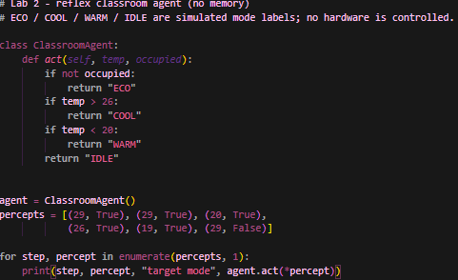

Expected output: COOL, COOL, IDLE, IDLE, WARM, ECO
Actual output:
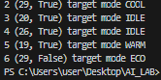
Reflex agent COOL do baar deta hai, kyunke usko yaad nahi ke pichli command pehle hi COOL thi.

Python Program: Stateful Agent (lab2_model.py)
Agent ab previous_mode yaad rakhta hai aur (previous, target, send_command) return karta hai. Thresholds aur occupancy priority wahi rakhi gayi hain.
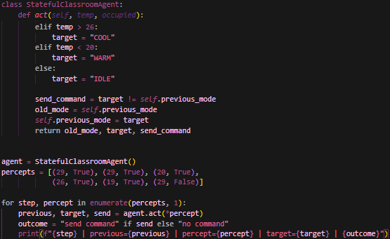

Actual output:
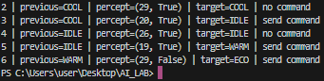

Mode-transition trace:
Step | Previous mode | Percept | Target | Command
1 | None | (29, True) | COOL | send command
2 | COOL | (29, True) | COOL | no command (repeat)
3 | COOL | (20, True) | IDLE | send command (boundary 20)
4 | IDLE | (26, True) | IDLE | no command (boundary 26)
5 | IDLE | (19, True) | WARM | send command (transition)
6 | WARM | (29, False) | ECO | send command (empty room)

Reflex vs Stateful Comparison
Point | Reflex agent | Stateful agent
Memory | Koi nahi | Previous mode yaad rakhta hai
Repeated percept | Same command dobara bhejta hai | Dobara command nahi bhejta
Return value | Sirf target mode | Previous, target, send flag
Learning | Nahi | Nahi (sirf last mode yaad, data se seekhna nahi)

Edge Case / Failure Analysis
Input: noisy temperature sequence 25.9, 26.1, 25.9, 26.1, 25.9, 26.1 (occupied room).
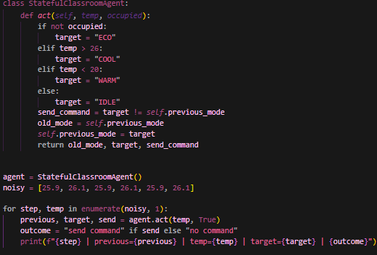

Observed behavior: target IDLE aur COOL ke beech baar baar badalta hai aur har step par command bhejta hai.
Likely cause: sirf pichla mode yaad rakhne se hysteresis nahi banta. 26 ka threshold itna sakht hai ke chhota sa noise mode badal deta hai.
Proposed improvement: hysteresis lagao, jaise COOL tab shuru ho jab temp > 26 ho aur tab tak chalta rahe jab tak temp < 25 na ho jaye.

Classical vs LLM-based Agent
Classical agent mein fixed rules aur explicit state hoti hai (jaise hamara classroom agent), is liye uska behavior predictable aur traceable hota hai. LLM-based agent natural language samajh ke tools use karta hai, lekin uska output probabilistic hota hai aur galat (unsupported) bhi ho sakta hai, is liye usko source checking aur human escalation chahiye.

Limitations
Classroom script simple, deterministic simulator hai aur isme sensor faults ya comfort ka model nahi hai. Stateful agent hysteresis nahi deta. PEAS sirf task environment describe karta hai, ye khud rational policy implement nahi karta.

Reflection
What did you learn today? Agent, percept, action aur PEAS ka farq, aur ye ke state yaad rakhna aur data se seekhna alag cheezein hain.
How will you apply this? Real system design mein pehle PEAS likhungi aur performance measure mein safety shamil karungi.
What failed or surprised you? Noisy values par stateful agent bhi baar baar mode badalta hai.
What would you do differently? Hysteresis wala version bana kar test karungi.

Responsible Practice
Performance measure mein sirf speed ya task completion nahi, safety aur constraints bhi hone chahiye. Saari values synthetic hain aur koi hardware control nahi hota.

